Q-Agent

Installation manual

Version 1.3

Steps to install the Q-Agent

- Make ActiveSync connection to the host PC
- Start setup program
- Install program will prompt you to install .NET Compact Framework 2.0. If you haven't installed it before, please install it
- Next you will be offered to install Q-Agent application
- The next required component is SQL Mobile. If you haven't installed it before, follow the instructions on the screen to install it
- Setup will ask you to put a connection key and password

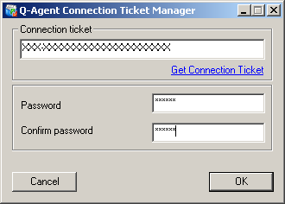

- This one is used to synchronize data with your Quick Books Online account. If you haven't got the connection key do the following:
  - Go to Online Edition Connection Setup for Q-Agent
  - Click on "Proceed to login page" button

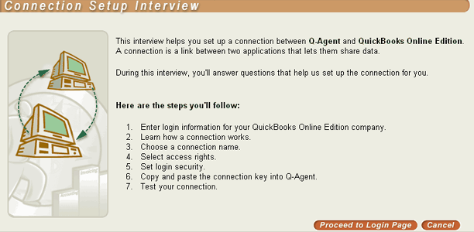

  - Enter your Login/Password and click on "Login" button or press enter

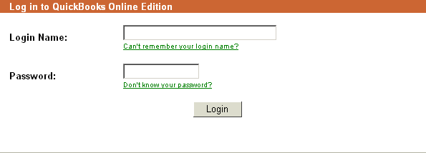

  - Click "Continue" button

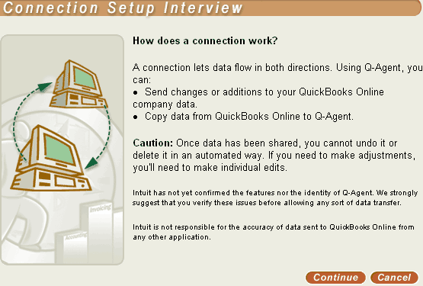

  - Click on "Create New Connection" button
  - Enter Connection Name, for example "Q-Agent connection" and Click "Continue" button

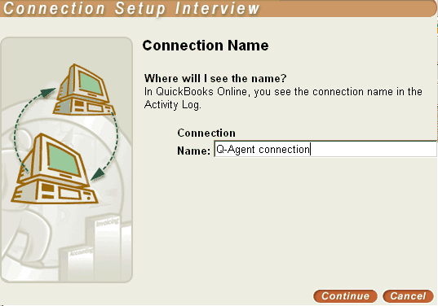

  - Choose Access Rights and click "Continue" button

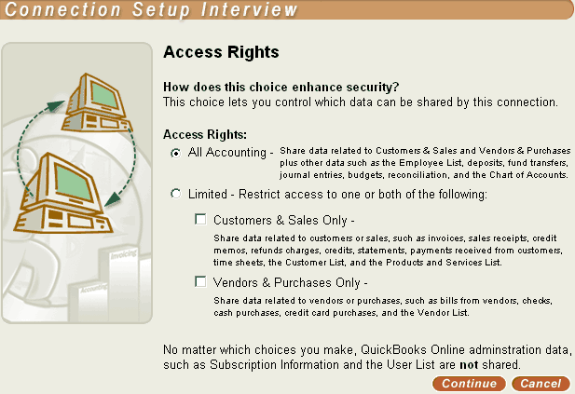

  - Choose Security type. Please choose "NO" to login security. Intuit does not allow us to get QB Online UserId and password from users. If you select another security type Q-Agent won't work properly. Your connection sill 100% secure since connection key will be encrypted on the device

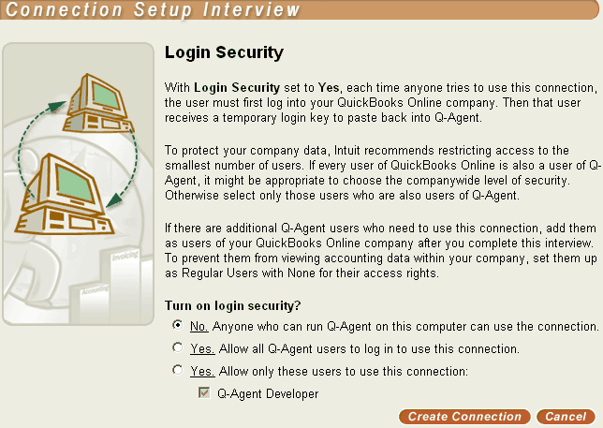

  - Please choose "I still want to turn off login security" when asked by Pop Up dialog
  - Now you have the connection ticket

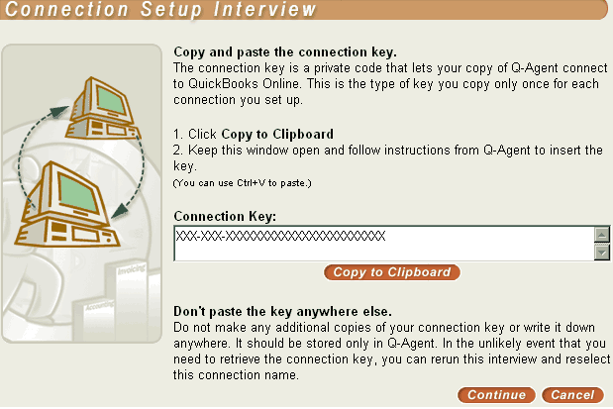

- Enter the connection ticket and any password (not QB Online password). This password will be used to encrypt connection key. Q-Agent will ask you for this password during synchronization. Ticket Manager application will be available on your host PC, so you will be able to change your password and connection ticket whenever you want
- Go to "Programs" menu on your device and run Q-Agent application
- If you have specified connection ticket, synchronize button will be available
- Run the first time synchronization to get data from your Quick Books Online account

